ICT SBA Report

Po Leung Kuk W.H.Cheung No.1 College
2024 - 2025

6D 08
Chau Ching Hoi
目录
Input Process Output 2
Mastermind Game User IPO Flow Document 3
Initial Game Startup 3
Main Command Loop 4
Command: customize_difficulty 4
Command: cheat 5
Command: save 5
Command: load 6
Command: start 6
Command: soc (Set Own Code) 7
Error Handling 8
Flow Chart 8
Pseudo code 9
Function 10
Variable Dictionary 11
C++ Prototyping 12
Testing 20

Input Process Output

Mastermind Game User IPO Flow Document
This document outlines the Input, Processing, and Output (IPO) flow for the user interacting with the Mastermind game .
Overview
The Mastermind game generates a secret code consisting of a sequence of digits (default: 4 digits, range 1–6) and allows the user up to a maximum number of attempts (default: 10) to guess it. The user receives feedback after each guess: red pegs indicate correct digits in the correct position, and white pegs indicate correct digits in the wrong position. The game supports various commands to customize difficulty, save/load games, cheat, set a custom code, or exit. The IPO flow is detailed below, covering the main user interactions.
IPO Flow

Initial Game Startup
- Input: None initially; the game starts automatically when the program is executed.
- Processing:
  - The main() function calls gamepage() to display the game introduction and rules.
  - A random seed is set using srand((unsigned)time(NULL)) for code generation.
  - A secret code is generated using generateSecretCode(codeLength, range) with default values (codeLength = 4, range = 6), producing a 4-digit code with digits from 1 to 6 (e.g., "2534").
  - Global variables are initialized: attempts = 0, latestguess = "", and secretCode is set.
  - The program prompts the user for the first command (firstcommand).

- Output:
  - Displays the game introduction, rules, and special commands via gamepage():
  - ===================================
  - MASTERMIND GAME
  - ===================================
  - Welcome to Mastermind!
  - Game Rules:
  - 1. A secret code of 4 digits (1-6) is generated.
  - 2. You have 10 tries to guess the code.
  - 3. Feedback after each guess:
  - - Red Peg: Correct digit in correct position
  - - White Peg: Correct digit in wrong position
  - Special Commands:
  - cheat -> Show the secret code
  - save -> Save your current game
  - load -> Load your saved game
  - exit -> Exit the game
  - customize_difficulty -> Change game settings e.g. code length, range and maxattempts
  - start -> Start a new game
  - soc -> set own code

Main Command Loop
- Input: User enters a command (firstcommand) via cin >> firstcommand.
- Processing:
  - The handle_command() function processes the input command.
  - Valid commands include:
    - customize_difficulty: Calls customize_difficulty() to adjust game settings.
    - exit: Initiates the exit process via tryagain().
    - cheat: Displays the secret code via cheatmode().
    - save: Saves the game state via savegame().
    - load: Loads a saved game state via loadgame().
    - start: Starts a new game by calling game().
    - soc: Allows the user to set their own secret code.
    - Any other input is validated via Input_validation() to check if it matches the expected code length (default: 4 digits).
  - If the input is invalid, the program prompts for a new command or restarts main() for certain cases.
- Output:
  - Depends on the command processed (detailed below).

Command: customize_difficulty
- Input:
  - User inputs values for code length, range, and max attempts when prompted.
- Processing:
  - The customize_difficulty() function calls getdifficulty() for each parameter.
  - For range, input is validated to ensure it is between 1 and 10.
  - Updates global variables codeLength, range, and maxAttempts.
- Output:
  - Displays the updated settings, e.g.:
  - Enter the value of code length (default is 4): 5
  - Enter the value of range (default is 6): 8
  - Enter the value of max attempts (default is 10): 12
  - Code length: 5, Range: 1-8, Max attempts: 12
Command: exit
- Input: User types exit.
- Processing:
  - Calls tryagain() to prompt the user to play again (Y or N).
  - If Y or y, restarts main().
  - If N or n, exits the program via exit(0).
- Output:
  - Displays:
  - Goodbye!
  - try again? (Y/N):
  - If invalid input (not Y, y, N, or n), prompts again:
  - Invalid input. Please enter Y or N:

Command: cheat
- Input: User types cheat.
- Processing:
  - Calls cheatmode(secretCode) to reveal the secret code.
- Output:
  - Displays the secret code, e.g.:
  - The secret code is: 2534

Command: save
- Input:
  - User types save.
  - User inputs a game file slot (0–4) when prompted.
- Processing:
  - Calls savegame(secretCode, latestguess).
  - Reads existing content from savegame.txt into an array.
  - Updates the array with current game state: currentgamefile, codeLength, range, maxAttempts, attempts, secretCode, and latestguess.
  - Writes the updated array back to savegame.txt.
- Output:
  - Displays confirmation and game state, e.g.:
  - save which game file? (0/1/2/3/4): 1
  - Game saved successfully.
  - current game file: 1
  - code length: 4
  - range: 6
  - max attempts: 10
  - attempts: 2
  - secret code: ****
  - latest guess: 1234

Command: load
- Input:
  - User types load.
  - User inputs a game file slot (0–4) when prompted.
- Processing:
  - Calls loadgame(secretCode, latestguess).
  - Reads all lines from savegame.txt into an array.
  - If the selected slot is empty, informs the user and returns.
  - Otherwise, updates global variables: currentgamefile, codeLength, range, maxAttempts, attempts, secretCode, and latestguess.
- Output:
  - Displays confirmation and game state, or an error if the slot is empty, e.g.:
  - load which game file? (0/1/2/3/4): 1
  - Game loaded successfully.
  - current game file: 1
  - code length: 4
  - range: 6
  - max attempts: 10
  - attempts: 2
  - secret code: ****
  - latest guess: 1234
Or:
No saved game in this slot.

Command: start
- Input: User types start.
- Processing:
  - Calls game(secretCode, codeLength, range, maxAttempts, latestguess).
  - Starts the timer using start_timer().
  - Enters a loop where the user guesses the code or enters commands.
  - For each guess:
    - Validates input length via Input_validation().
    - Checks if the input is a command via handle_command().
    - If the input is a valid guess (all digits), increments attempts, computes feedback using redpegs() and whitepegs(), and checks win/loss conditions.
    - If the guess matches secretCode, the game ends with a win.
    - If attempts reaches maxAttempts, the game ends with a loss.
  - Stops the timer using stop_timer() when the game ends.
  - Calls tryagain() to prompt for a new game.
- Output:
  - For each guess, displays feedback and remaining attempts, e.g.:
  - Enter your guess (or type 'exit', 'save', 'load', 'cheat', 'customize_difficulty', 'start', 'soc'): 1234
  - Number of red pegs: 1
  - Number of white pegs: 2
  - You have used 1 out of 10 attempts.
  - You have 9 attempts left.
  - On win:
  - Congratulations! You've guessed the secret code: 2534
  - Elapsed time: 45 seconds.
  - try again? (Y/N):
  - On loss:
  - You've used all attempts! The secret code was: 2534
  - Elapsed time: 60 seconds.
  - try again? (Y/N):

Command: soc (Set Own Code)
- Input:
  - User types soc.
  - User inputs their own secret code.
- Processing:
  - Updates secretCode with the user’s input.
  - Sets codeLength to the length of the input code.
- Output:
  - Prompts for the code, e.g.:
  - Enter your own secret code: 9876
Default Guess Input
- Input: User enters a guess (e.g., 1234) that is not a recognized command.
- Processing:
  - Validates the input length via Input_validation().
  - If valid (matches codeLength), checks if the input consists of digits using isdigit().
  - If valid digits, the program assumes the game has started and processes the guess in game() (increments attempts, computes feedback, etc.).
  - If invalid, prompts for new input.
- Output:
  - If invalid length:
  - Invalid input. Please enter a 4-digit number:
  - If valid guess, feedback is shown as described in the start command.

Error Handling
- Input Validation:
  - Input_validation() ensures guesses match the expected code length or are valid commands.
  - getdifficulty() validates the range (1–10) for the range parameter.
  - tryagain() ensures the input is Y, y, N, or n.
- File Handling:
  - savegame() and loadgame() handle file operations with a fixed structure (5 slots, 7 lines each).
  - If a load attempt targets an empty slot, the user is notified.
Summary
The user interacts with the Mastermind game through a command-driven interface, entering commands or guesses to play, customize, save, load, or exit the game. Inputs are validated for length and type, processed to update game state or perform actions, and output as feedback, game state, or prompts. The game tracks time, attempts, and provides peg-based feedback to guide the user. Despite a few bugs (notably in whitepegs()), the IPO flow supports a functional code-breaking game with flexible user controls.

Flow Chart
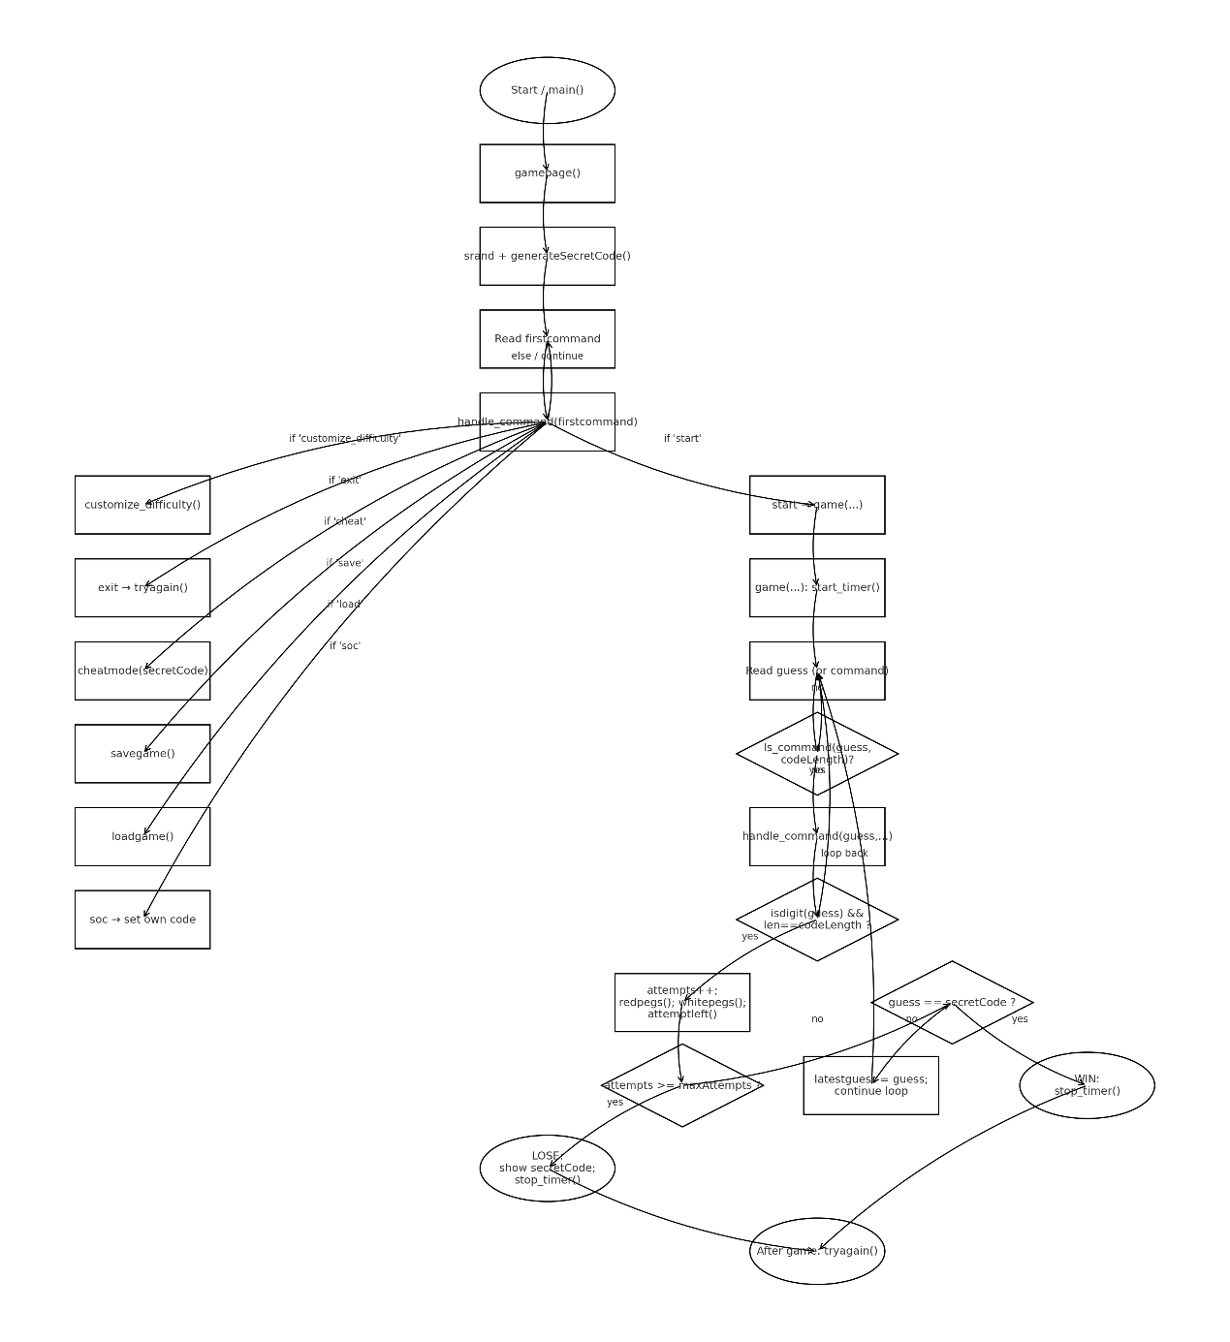

Pseudo code

Function
Function type | Function name | Function usage
String | generateSecretCode | Generate the code for guessing
Bool | Is_command | Determine whether the input is a command.
String | redpegs | Determine whether the guess has redpegs and find how many redpegs are there
String | whitepegs | Determine whether the guess has whitepegs and find how many whitepegs are there
Void | Getdifficulty | Input the word length

Variable Dictionary
Variable type | Variable name | Variable default value | Global / Local | Usage

C++ Prototyping
#include <iostream>//for input and output
#include <string>//for string handling
#include <ctime>//for rand()
#include <fstream>//for file handling
#include <chrono> // Add this include for timing
#include <cstdlib> // for exit()
using namespace std;
using namespace std::chrono; // in the timing functions

int codeLength = 4;
int range = 6;
int maxAttempts = 10;
int attempts = 0;
string secretCode;
string latestguess;
int currentgamefile = 0;

steady_clock::time_point startTime;
steady_clock::time_point endTime;

string generateSecretCode(int length, int range ) {
string code;
for (int i = 0; i < length; ++i) {
char digit = '0' + rand() % range + 1;
code += digit;
}
return code;
}

bool Is_command(string& input,int length) {
while (input.length() != length ) {
if (input == "exit" || input == "save" || input == "load" || input == "cheat" || input == "customize_difficulty" || input == "start" || input == "soc") {
return true; // allow commands to pass through
}
cout << "Invalid input. Please enter a " << length << "-digit number: ";
cin >> input;
}
return true;
}
string redpegs(string secretCode, string playerGuess) {
int correctPosition = 0;
for (int i = 0; i < secretCode.length(); ++i) {
if (secretCode[i] == playerGuess[i]) {
correctPosition++;
}
}
string output = "Number of red pegs: " + to_string(correctPosition);
return output;
}
string whitepegs(string secretCode, string playerGuess) {
int correctNumber = 0;
// Create frequency maps for secret and guess
int secretCount[10] = {0}; // Assuming digits 0-9
int guessCount[10] = {0};

for (char c : secretCode) {
secretCount[c - '0']++;
}
for (char c : playerGuess) {
guessCount[c - '0']++;
}

// Calculate total matches
int totalMatches = 0;
for (int i = 0; i < 10; ++i) {
totalMatches += min(secretCount[i], guessCount[i]);
}

// Subtract red pegs (correct position matches)
int redPegs = 0;
for (size_t i = 0; i < secretCode.length(); ++i) {
if (secretCode[i] == playerGuess[i]) {
redPegs++;
}
}

correctNumber = totalMatches - redPegs;

string output = "Number of white pegs: " + to_string(correctNumber);
return output;
}
void getdifficulty( string category, int& defaultValue) {
cout << "Enter the value of " << category << " (default is " << defaultValue << ") : " << endl;
cin >> defaultValue;
if (category == "range"){
while (defaultValue < 1 || defaultValue > 10) {
cout << "Invalid range. Must be between 1 to 10." << endl;
cin >> defaultValue;
}
}
}

void customize_difficulty(){
getdifficulty("code length", codeLength);
getdifficulty("range", range);
getdifficulty("max attempts", maxAttempts);
cout << endl ;
cout << "Code length: " << codeLength << ", Range: 1-" << range << ", Max attempts: " << maxAttempts << endl;
cout << endl ;
}
void cheatmode(string secretCode) {
cout << "The secret code is: " << secretCode << endl;
}
void attemptleft(int attempts, int maxAttempts) {
cout << "You have used " << attempts << " out of " << maxAttempts << " attempts." << endl;
cout << "You have " << (maxAttempts - attempts) << " attempts left." << endl;
cout << endl ;
}// only for typing less in main() lazy me :)

void start_timer(){
startTime = steady_clock::now();
}// chrono library
// i dont think i need to explain this one :)

void stop_timer(){
endTime = steady_clock::now();
auto duration = duration_cast<seconds>(endTime - startTime).count();
cout << "Elapsed time: " << duration << " seconds." << endl;
}// same as above :)

void gamepage(){
cout << "===================================" << endl;
cout << " MASTERMIND GAME " << endl;
cout << "===================================" << endl;
cout << " Welcome to Mastermind! " << endl;
cout << endl;
cout << "Game Rules:"<< endl;
cout << "1. A secret code of 4 digits (1-6) is generated." << endl;
cout << "2. You have 10 tries to guess the code." << endl;
cout << "3. Feedback after each guess:"<< endl;
cout << " - Red Peg: Correct digit in correct position" << endl;
cout << " - White Peg: Correct digit in wrong position" << endl;
cout << endl;
cout << "Special Commands:" << endl;
cout << "cheat -> Show the secret code" << endl;
cout << "save -> Save your current game" << endl;
cout << "load -> Load your saved game" << endl;
cout << "exit -> Exit the game" << endl;
cout << "customize_difficulty -> Change game settings e.g. code length, range and maxattempts " << endl;
cout << "start -> Start a new game" << endl;
cout << "soc -> set own code " << endl;
cout << endl ;
}
void savegame(string secretCode, string latestguess){
const int totalGames = 5;
const int linesPerGame = 7;
string lines[totalGames * linesPerGame] = {""};

// Read existing file lines
ifstream inFile("savegame.txt");
int idx = 0;
while (idx < totalGames * linesPerGame) {
getline(inFile, lines[idx]);
idx++;
}
inFile.close();

cout << "save which game file? (0/1/2/3/4): ";
cin >> currentgamefile;
int base = currentgamefile * linesPerGame;

lines[base + 0] = to_string(currentgamefile);
lines[base + 1] = to_string(codeLength);
lines[base + 2] = to_string(range);
lines[base + 3] = to_string(maxAttempts);
lines[base + 4] = to_string(attempts);
lines[base + 5] = secretCode;
lines[base + 6] = latestguess;
//save the game in a string array
//overwrite only the current game corresponding lines

// Write all lines back including the original and updated
ofstream outFile("savegame.txt");
for (int i = 0; i < totalGames * linesPerGame; ++i) {
outFile << lines[i] << endl;
}
outFile.close();
//using for loop to put all line[35] into txt

cout << "Game saved successfully." << endl;
cout <<" current game file: " << currentgamefile << endl;
cout <<" code length: " << codeLength << endl;
cout <<" range: " << range << endl;
cout <<" max attempts: " << maxAttempts << endl;
cout <<" attempts: " << attempts << endl;
cout <<" secret code: " << "****" << endl;
cout <<" latest guess: " << latestguess << endl;
//debugging
}

void loadgame(string &secretCode, string &latestguess){
const int totalGames = 5;
const int linesPerGame = 7;
string lines[totalGames * linesPerGame] = {""};

ifstream inFile("savegame.txt");
int idx = 0;
while (idx < totalGames * linesPerGame) {
getline(inFile, lines[idx]);
idx++;
}
inFile.close();
//read all lines in txt
//getline usage: getline; getline; getline; --> line1 line2 lin3

cout << "load which game file? (0/1/2/3/4): ";
cin >> currentgamefile;
int base = currentgamefile * linesPerGame;
//1-7 line for game0 8-14line for game1 and so on
// Read from the slot
if (lines[base].empty()) {
cout << "No saved game in this slot." << endl;
return;
}
currentgamefile = stoi(lines[base + 0]);
codeLength = stoi(lines[base + 1]);
range = stoi(lines[base + 2]);
maxAttempts = stoi(lines[base + 3]);
attempts = stoi(lines[base + 4]);
secretCode = lines[base + 5];
latestguess = lines[base + 6];
//same as savegame
//stoi is string to int

cout << "Game loaded successfully." << endl;
cout <<" current game file: " << currentgamefile << endl;
cout <<" code length: " << codeLength << endl;
cout <<" range: " << range << endl;
cout <<" max attempts: " << maxAttempts << endl;
cout <<" attempts: " << attempts << endl;
cout <<" secret code: " << "****" << endl;
cout <<" latest guess: " << latestguess << endl;
//debugging
}

void tryagain();
void game(string secretCode, int codeLength, int range, int maxAttempts, string latestguess);
bool handle_command(string &firstcommand, string &secretCode, string &latestguess);

bool isdigit(string c) {
for (int i = 0; i < c.length(); ++i) {
if (c[i] < '0' || c[i] > '9') {
return false;
}
}
}

void game(string secretCode, int codeLength, int range, int maxAttempts, string latestguess) {
start_timer(); // Start the timer at the beginning of the game
while (true) {
string guess;
cout << "Enter your guess (or type 'exit', 'save', 'load', 'cheat', 'customize_difficulty', 'start', 'soc'): ";
cin >> guess ;
Is_command(guess,codeLength);
handle_command(guess, secretCode, latestguess);
if (isdigit(guess) && guess.length() == codeLength) {
attempts++;
cout << redpegs(secretCode, guess) << endl;
cout << whitepegs(secretCode, guess) << endl;//real game part, only 3 lines lmao
attemptleft(attempts, maxAttempts) ;
}
if (attempts >= maxAttempts) {
cout << "You've used all attempts! The secret code was: " << secretCode << endl;
stop_timer();
break;
}

if (guess == secretCode) {
cout << "Congratulations! You've guessed the secret code: " << secretCode << endl;
stop_timer(); // Show time used when game ends
break;
}
latestguess = guess;
}
}

int main(){
gamepage();
string firstcommand;
srand((unsigned)time(NULL));
secretCode = generateSecretCode(codeLength, range);
cin >> firstcommand;
attempts = 0;
latestguess = "";
//firstcommand is the starter command
while (true) {
if (!handle_command(firstcommand, secretCode, latestguess)) break;
cin >> firstcommand;
}
return 0;
}

//try again?
void tryagain(){
cout << "try again? (Y/N): ";
char tryAgain;
cin >> tryAgain;
while (tryAgain != 'Y' && tryAgain != 'y' && tryAgain != 'N' && tryAgain != 'n') {
cout << "Invalid input. Please enter Y or N: ";
cin >> tryAgain;
}
if (tryAgain == 'Y' || tryAgain == 'y') {
main(); // Restart the game
} else {
cout << "Goodbye! press any key to exit" << endl;
exit(0); // Exit the program
}
}

bool handle_command(string &firstcommand, string &secretCode, string &latestguess) {
if (firstcommand == "customize_difficulty") {
customize_difficulty();
} else if (firstcommand == "exit") {
cout << "Goodbye!" << endl;
tryagain();
return false; // break loop
} else if (firstcommand == "cheat") {
cheatmode(secretCode);
return true; // continue loop
} else if (firstcommand == "save") {
savegame(secretCode, latestguess);
} else if (firstcommand == "load") {
loadgame(secretCode, latestguess);
} else if (firstcommand == "start") {
cout << "Starting a new game..." << endl;
game(secretCode, codeLength, range, maxAttempts, latestguess);
tryagain();
return false; // break loop
} else if (firstcommand == "soc") {
cout << "Enter your own secret code: ";
cin >> secretCode;
codeLength = secretCode.length();
} else if (Is_command(firstcommand, codeLength)) {
return true; // continue loop
} else {
cout << "Invalid command. Please try again." << endl;
main();
return false; // break loop
}
return true; // continue loop
}

Testing

Testing 1
Testing sample | Sample remark (reason of using this sample) | Expected result
Run program and enter /1 to start game, then guess "1234" (use /7 to set it) | Tests basic game start, guess processing, and immediate win | Game starts, shows feedback with 4 red pegs, congratulates on win in 1 attempt, stops timer, sets gamestarted=false
Result:
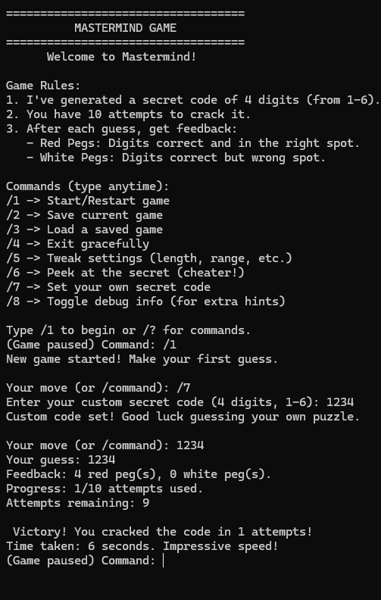

Testing 2
Testing sample | Sample remark (reason of using this sample) | Expected result
After starting game (/1), enter guess "abcd" | Tests invalid non-digit input validation | Prints "Guesses must be digits only (no letters or symbols).", does not increment attempts, does not show pegs
Result:
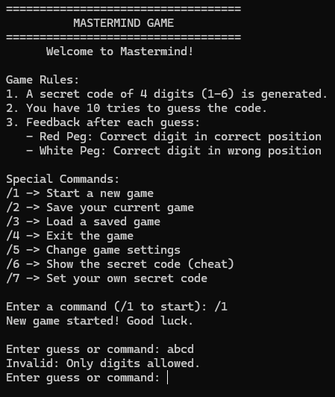

Testing 3
Testing sample | Sample remark (reason of using this sample) | Expected result
After starting game, enter guess "123" (if codeLength=4) | Tests invalid length validation | Prints "Guess must be 4 digits long.", does not increment attempts
Result:
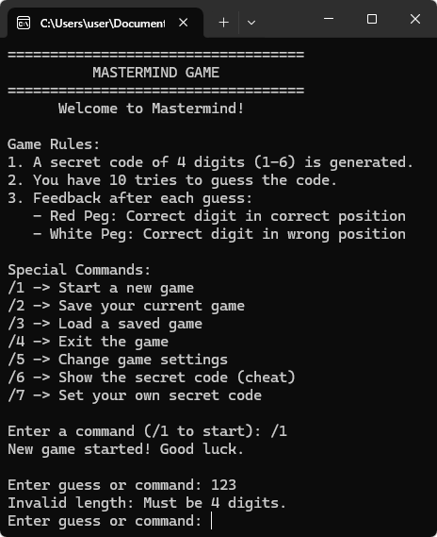

Testing 4
Testing sample | Sample remark (reason of using this sample) | Expected result | Actual result | Meet expectation
After starting game, enter /6 | Tests cheat mode command during active game | Prints "Cheat mode activated! The secret code is: [code]", continues game
Result:
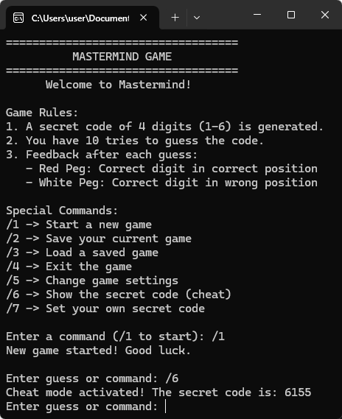

Testing 5
Testing sample | Sample remark (reason of using this sample) | Expected result
After starting game, enter /2 to save | Tests save functionality | Prompts for slot, saves to file, prints confirmation, shows debug if enabled
Result:
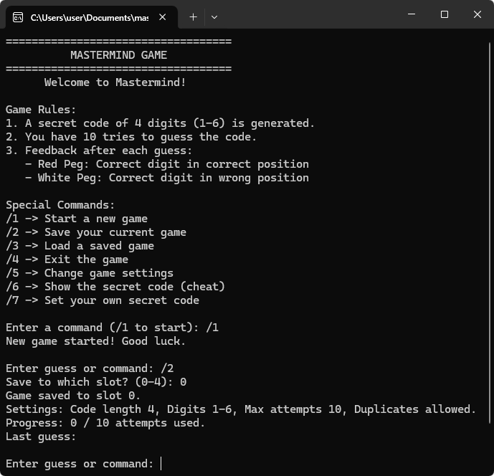

Testing sample | Sample remark (reason of using this sample) | Expected result
After starting game, enter /2 to save | Tests save functionality | Prompts for slot, saves to file, prints confirmation, shows debug if enabled
Enter /3 to load from slot 0 (after saving) | Tests load functionality | Prompts for slot, loads settings/code/attempts, resumes game with message
Enter /5, change codeLength to 5, then /1 | Tests difficulty customization and regeneration | Updates settings, generates new 5-digit code on restart
After starting game with allowDuplicates=false, enter guess with duplicate like "1123" (length=4) | Tests duplicate validation in guess | Prints "No duplicate digits allowed in your guess.", does not process
Start game, make maxAttempts guesses without winning | Tests loss condition | After last attempt, shows game over with secret code, stops timer
Enter /8 | Tests debug mode toggle | Toggles debugMode, prints status message
After starting game, enter guess "5678" (assuming secret "1234") | Tests guess with no matches (0 red, 0 white) for full miss | Shows "Feedback: 0 red peg(s), 0 white peg(s).", increments attempts, shows progress
After starting game, enter guess "1245" (assuming secret "1234") | Tests partial match: 3 red, 0 white (last digit wrong) | Shows "Feedback: 3 red peg(s), 0 white peg(s).", increments attempts
After starting game, enter guess "2134" (assuming secret "1234") | Tests position shift: 0 red, 4 white (all correct digits, wrong positions) | Shows "Feedback: 0 red peg(s), 4 white peg(s).", increments attempts
After starting game, enter guess "1324" (assuming secret "1234") | Tests mixed pegs: 2 red, 2 white (swapped middle digits) | Shows "Feedback: 2 red peg(s), 2 white peg(s).", increments attempts
After starting game, enter guess "0000" (digits below 1) | Tests invalid low-range digit validation | Prints "Digits must be between 1 and 6.", does not increment attempts
After starting game, enter guess "7777" (digits above range=6) | Tests invalid high-range digit validation | Prints "Digits must be between 1 and 6.", does not increment attempts
After starting game with allowDuplicates=true, enter guess "1111" (all duplicates) | Tests allowance of duplicates in guess when enabled | Processes guess, shows pegs based on matches (e.g., if secret has 1s), increments attempts
After starting game, enter a valid guess like "1234" that matches secret exactly | Tests win condition mid-game | Immediately congratulates on win, stops timer, ends game session
After starting game, enter guess with leading/trailing spaces like " 1234 " | Tests input trimming (if implemented) or rejection for non-digits | If no trim, rejects as invalid length/non-digits; else processes as "1234"
After starting game, enter very long guess like "123456789" (length>codeLength) | Tests length validation for oversized input | Prints "Guess must be 4 digits long.", does not increment attempts

